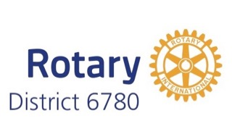 | District Grant Timeline  2025-2026 | 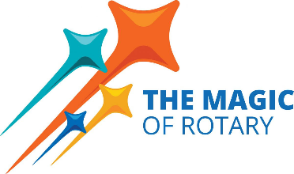

- Project Planning
  - President-Elect year: the Club identifies its District Grant project for Rotary Year 2025-2026.

- Club Qualification
  - Two Club members (President-Elect and project lead recommended) attend District grant qualification training during Rotary year 2024-2025.
  - The Club Memorandum of Understanding and Club Qualification Plan (one combined document) must be submitted for the grant proposal to be considered (may be submitted with the application).

- Application
  - Applications for the District Grants are accepted between October 27, 2024, and January 31, 2025.
  - Grants applications will be reviewed, and approvals announced beginning in February 2025.

- Funding
  - Clubs may expect to get a grant for half of the project cost, up to the Club allocation.
  - Clubs should immediately notify the District Grant team if their project cannot be completed – this allows the funds to be reallocated to Clubs with pending projects.

- Execution
  - Work on Club projects may not begin until the Club has been notified by the District that The Rotary Foundation has approved the District 6780 District grant package for 2025-2026 Year! (This should occur by June 1, 2025.)
  - Target date for District Grant completion: March 31, 2026

- Progress Report
  - A progress report is due on October 1, 2025.

- Completion
  - The Project, except for the final report, should be completed by March 31, 2026.

- Closing Report
  - A final report with receipts should be submitted within two months of completion of the project, but no later than May 31, 2026.
  - Reimbursement by the District grant will occur after the final report is approved and the funds have been transferred to the District by The Rotary Foundation.

